**VMWare Tools Update procedure:**

Please follow below steps to update VMware tools on Linux VM.

1. Take VM downtime (approx. 1 hr) approval from Application Team.
2. **Raise metis incident for VMWare Team to attach the VMware tools ISO to VM.**
3. Take VM prechecks.
4. Take VM snapshot.
5. Put server in the downtime in NOSUP portal (For Production servers).
6. Once ISO is attached to VM, mount VMware tools ISO on the VM.
7. Copy VMwareTools tar file to /tmp, untar it. Run the Perl script & just go with default values (hit enter key for all options).
8. Reboot the server & check the OS functionality & VMware tools status on the Vcenter.
9. Send mail to Application Team to check their application functionality.
10. If server is OK from Application end (confirmation from Apps Team), then delete snapshot.
11. Rollback: If application/OS not function fine then we can restore the VM snapshot.

**Steps with commands & screenshots:**

1. Raise metis incident for VMWare Team to attach the VMware tools ISO to VM**.**
2. Mount VMware tools ISO on the VM as under.

[root@hlmupt1exefo ~]# mount /dev/sr0 /mnt/

[root@hlmupt1exefo ~]# df -ThP /mnt/

1. Copy “**VMwareTools-10.3.21-14772444.tar.gz**” tar file to /tmp & untar it.

[root@hlmupt1exefo ~]# cp -v VMwareTools-10.3.21-14772444.tar.gz /tmp/

[root@hlmupt1exefo ~]# cd /tmp/

[root@hlmupt1exefo ~]# tar -xvzf VMwareTools-10.3.21-14772444.tar.gz

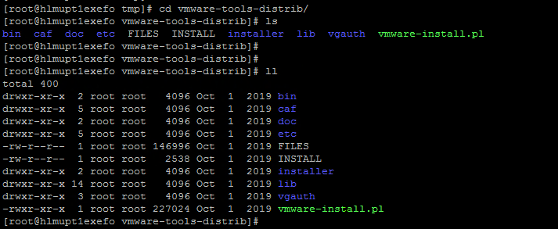

1. Then go to **vmware-tools-distrib** directory & run “**vmware-install.pl**” script & just go with default values (hit enter key for all options).

[root@hlmupt1exefo ~]# cd vmware-tools-distrib/

[root@hlmupt1exefo ~]#./vmware-install.pl

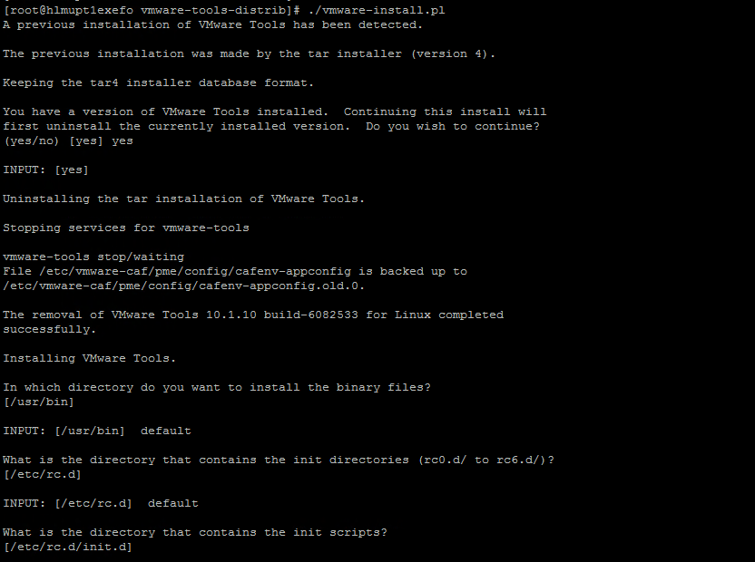

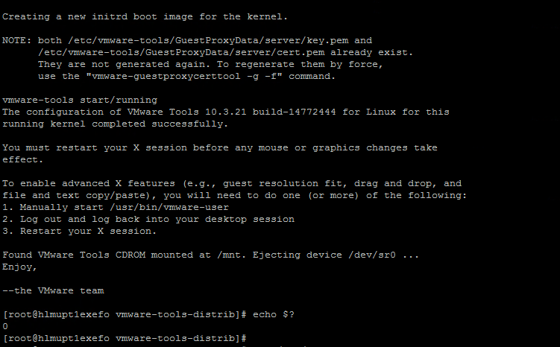

[root@hlmupt1exefo ~]# ps -ef | grep vmtool

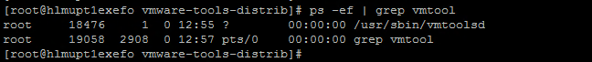

**Before:**

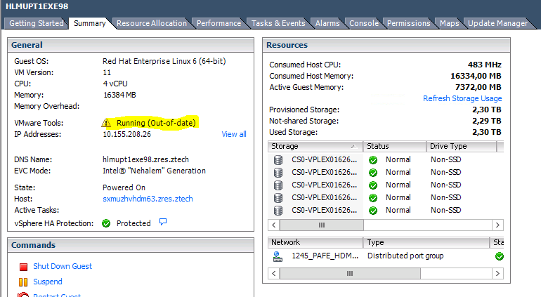

**After:**

